Work Experience:

Trainee Development
- Participated as an instructor in high school cadet official on-field training exercises (1962)
- Participated as an instructor in high school cadet official classroom training courses (1962)
- Organized and presented the Season Study Group (2014)

NCAA Varsity Experience

2015 Season
- Saturday, April 18, 2015 University of You Called It Spring Game (R)

2014 Season
- Saturday, April 19, 2014 University of That’s The One Spring Game (U)
- Thursday, August 23, 2014 That College @ This University (HL)

NCAA Post Season Experience
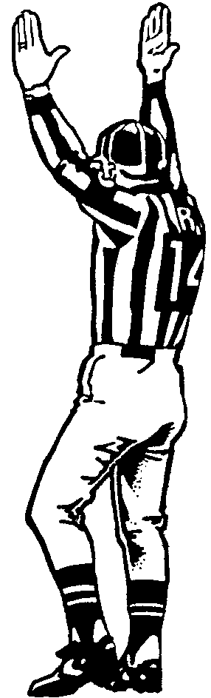
- Friday, December 19, 2014 Bowl

Stewart Griffen

123 Edgar Avenue

New York, NY

CELL: (123) 456-7890 EMAIL: stewie@familyguy.com
  - (Conference) School vs. (Conference) School (Position)

High School Varsity Experience

2004 Season
- Friday, September 16, 2004 HS @ HS (HL)

High School Varsity Playoff Experience
- Friday, November 19, 2005 State, Division, Group, etc. Round
  - (Seed) High School vs. (Seed) High School (LJ)

Clinics Attended
- March 27-28, 200_ ABC Football Officials Clinic (B)
- April 17-18, 200_ XYZ Football Officials Clinic (LJ)

Affiliations

1. Athletic Association (registered official) since 1975

2. Officials Association (member) since 1980

3. Semipro Football League (official) 2000-2005

